The Principle of Geotagging.

Cross-linking archival sources with people and the city through digital urban places.

Christoph Breser, Univ.-Ass. Mag.phil.
Institute of Structural Design
Faculty of Architecture, Graz University of Technology
Graz, Austria
christoph.breser@tugraz.at

Stefan Zedlacher, Dipl.Ing.
Institute of Art History
Faculty of Arts and Humanities, University of Graz
Graz, Austria
stefan.zedlacher@uni-graz.at

Ramona Winkler, BSc
Faculty of Architecture
Graz University of Technology
Graz, Austria
r.winkler@tugraz.at

Abstract—This article discusses technical solutions for representing archival sources in urban areas. We strive to realise the interconnectedness of sources, its beholders and the concerning entity through the location where the information got recorded the first time. This will be exemplified by a recent project at the University of Graz. Thereto, we need to identify problems in the analogue world mainly dealing with the classification of archiving, semiotic systems, descriptions and assignments. We use existing mobile technologies and software applications from different application fields and test their suitability for our concern. Comparing and transferring analogue methods to the digital world is a real challenge we like to accept when it comes to solving identified problems that arise in the context of modes of practice in archives and web representations.
Keywords—geotagging; augmented reality; Graz; Heinrich von Geymueller; reference; semantic web; metadata; digital semantic web; digital archive; architecture-related archive.

Introduction
We got the awareness of the problem addressed in this paper during our work on a recent research project that started in December 2014. The project especially refers to the handling of architecture-related archival sources [1]. It intends to digitalise the scientific legacy of the Swiss historian of architecture Heinrich von Geymueller (1839–1909). This legacy has been situated at the Institute of Art History at the University of Graz since 1927. At the beginning, our work concentrated on the preparation of a suitable web representation. Purposes of digitalisation of more than 71,500 single objects eventually encouraged ideas focussing on the optimisation of message qualities of archival sources.
Traditional and analogous work in archives has been experiencing innovations for years, in terms of the digitalisation of archival materials. Renovation, retention, and order have substantially changed through the inclusion of information technologies. The data recorded and systematized in the archive will be transferred, stored and thereby provided to users in the World Wide Web, autonomous from time and space. Digitalisation can imply the occurrence of mistakes. The use of different browsers or software preferences often gives rise to deviations. The majority of archives works with searchable metadata. The latter are easy to incorporate and flexibly applicable. But, incorporating metadata often leads to inconsistencies. Such data are indeed necessary for administrating archival materials, but it is of limited interest to the World Wide Web, because essential information, like being in conjunction with contents, is completely left out or is not possible at all.
The following chapters discuss several problem positions concerning the handling of different archive sources by using digital methods. Results are presented directly afterwards. The case study will give an overview of concrete implementation possibilities.

First Analysis: Problems in dealing
with different sementics
The preparation of web representation approaches was preceded by investigations and observations. These investigations dealt with recent projects of digitalisation and established web representation practices. Our investigation exhibited that the transfer of architecture-related source materials in web applications needs special treatment due to different semantics (see II.A.). This insight led to a further discourse about the message quality of archival sources both inside and outside the archive. This discourse also comprised the question to what extent the message quality could be increased through localisation in the urban area (see III.C.). It has to be noted that a qualitatively good research result in a web application mostly requires expertise in dealing with sources.

II. A. Different mediality of architecture-related archival sources
Architecture-related archives normally show a broad spectrum of sources, that is richer than average. This became clear in a comparison of recent projects of digitalisation discussing various topical contents [2]. Historical legacies of the architects Herbert Eichholzer (Archive, Graz University of Technology), Heinrich von Geymüller (Archive of the Institute of Art History, University of Graz) and Clemens Holzmeister (Archive of Architecture, University of Innsbruck) make it exemplarily evident that particularly the categorical order of image and plan source requires a specific treatment. Initially, we generally differentiated between image and text sources:
Image sources are photos, graphics, prints, sketches, plan drawings or design drawings, etc. In general, they have to be described differently because of their imaging, rendering or instructing function. Plan and design materials can both be rendering and instructing and are either assigned to realised or not realised projects. In the case of Geymueller’s legacy it made matters worse that such image contents are also a question of notional depiction and / or reconstruction projects. Among a wide range of different image sources, as it is the case with Holzmeister’s legacy, which encompasses 239 plan and design drawings as well as more than 9,000 original photos, the three archives mentioned above additionally contain different genres of text sources.
Text sources are mainly represented by sketchbooks, notes and contemporary newspaper clips. The Geymueller case features a wealth of transcripts, excerpts, manuscripts, proofs, invoices, delivery notes, tables, and documents of correspondence like letters and postcards. This wealth is to be credited to the distinct research and publication activities Geymueller had undertaken. The notepads had to be differentiated in terms of published and unpublished contents. Handwritten notepads and sketches cover an enormous amount of the overall more than 71,500 objects of Geymueller’s legacy. Some of them are significant because they include unpublished information. These notepads and sketches are, together with many plan drawings, an exception, because they comprise both figurative and textual semantics.
Hybrid sources are denoted as such only if they contain both figurative depictions and textual parts, and thus can be analysed in terms of both image and linguistics. The hybrid sources in the three archives considered in our research primarily mattered in the form of sketches and sketchbooks, sometimes also in the form of plan materials and all types of design materials. In some exceptional cases, there were inscribed photographs and labeled letters, which did not allow a clear assignment to the classic image or text sources.
Audio and video sources are not available in our research project, but should be mentioned for the sake of completeness.

II. B. Full-text image search
Digitalising analogous data and processes into digital representations always involves a loss of meaning in favour of precision of the message [3]. The notion ‘semantic web’ signifies to integrate relations between digital data, such as image sources and text sources. In databases this is currently achieved by standardising metadata (Dublin Core [4], metadata encoding transmission standards (METS) [5], etc.) and by deploying methods of the text encoding initiative (TEI) [6] or the resource description framework (RDF) [7]. Since 2000 there has been a standard, the General International Standard Archival Description (ISAD-G), which unifies the presentation data of the world and inserts data into databases, recorded in a standardised manner [8].

The following problem for the web application results from this: Through the digitalisation and digital gathering of text, image, and / or hybrid sources, only a full-text search can be conducted on the basis of conventional methods so far. This current standard of searching cannot satisfy the central aspect of an archive presenting the entire stock as a collection of diverse relationships.

Results – The handling of different semantics and full-text image search was accomplished through a new data model. It is based on a reference-plane system that does not make any distinction between image and text-based data, but includes hybrid sources. The data model is presented in more detail in the case study (IV.). This reference-plane system focuses not only on the metadata but also on the performances of the content.

Second Analysis: Missing referential message qualities of archival sources in archives and web applications
The following observations and considerations were guided by theory-driven analyses and arose while we were working on the Geymueller archive legacy. Thereby, we realised semantic communications problems, which concern the work with sources in archives (analogue location) and also with representations in web applications (digital location). Recognised deficits resulting from that finally led to the consideration and review of opportunities to semantically reference archival sources to the location where the original uptake stems from.

III. A. The sum and performance of an archival source’s features

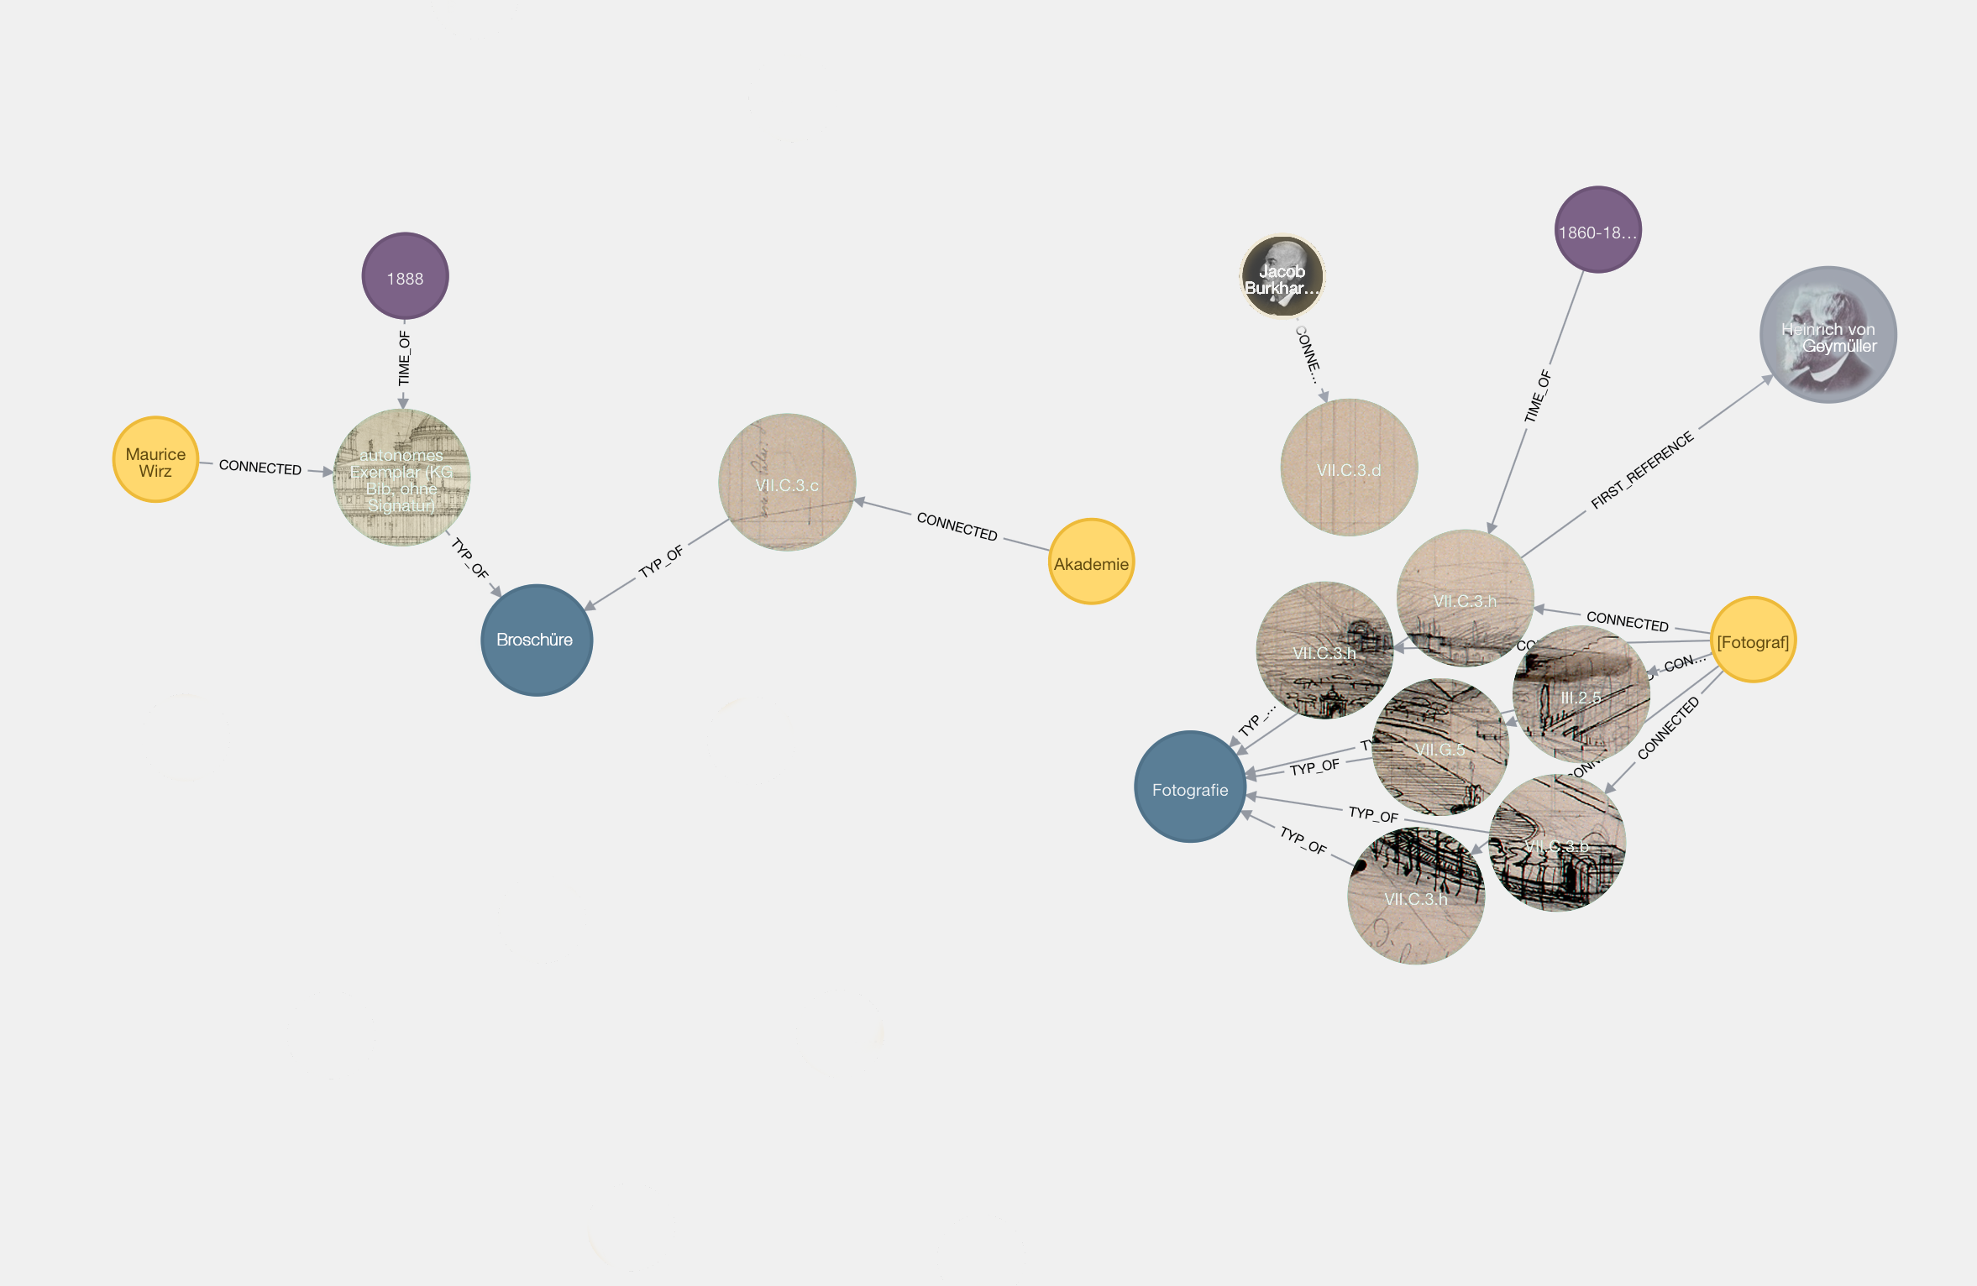
- Relation structure referring to Brunswick’s model: The sum and performance of an archival source’s features (Author)

- An archival source’s quality is viewed as subject to the sum of all features assigned to it (message) [9] and the features’ performances among each other (see III.A.) . Furthermore, references to one or several tangible or intangible objects / entities [10] outside of the archive (see III.C.). The first two “message values” - sum and performance - basically trace back to the model of the gestalt psychologist Christian von Ehrenfels as well as to observations of Egon Brunswik [11].
Ehrenfels realised that the result is not only the sum of parts in a whole, but also the perception and cognition of the whole conditioned by its parts – thus the whole is more than the sum of its parts [12]. Transferring this insight to an archival source, this means that an entire message about it can only be made, in an analogue sense, on the basis of the sum of all its parts’ features (material, formal, and content-related) in consideration of their relations or performance to each other. Examples for individual features are texture, origin, depicted content etc. Every individual message can only be interpreted properly by taking account of the source’s entire message. Altogether the messages eventually yield the first “message value”, which we term ‘the sum’. In the digital data processing, this value can be produced through appropriate visualisation methods and automatized information gathering, too [13].
The second “message value” is `the performance´ (see fig. 1), which is achieved through the consideration of relationships between individual messages. The coherence of parts observed by Brunswik [14] corresponds to the work in an archive insofar as the relationship between the message about the origin and the content are mutually dependent, for example, because a geographic indication related to an archival source can be a pointer to the content and conversely – provided that the relation to one or several other indications (see III.B.) or objects outside of the archive (see III.C.) can be confirmed [15].
What we were trying to reproduce by means of these two models firstly was for the first two values of the message quality, which applies through the summation of all individual messages and the consideration of its relationships to each other (see III.A.). It took many years after the models´ foundation until the digital image is today regarded as its best representative: Many different chromatophores (pixels), considered separately, result in an entire image. The respective proportion of them only arises through the image itself (see fig. 2).

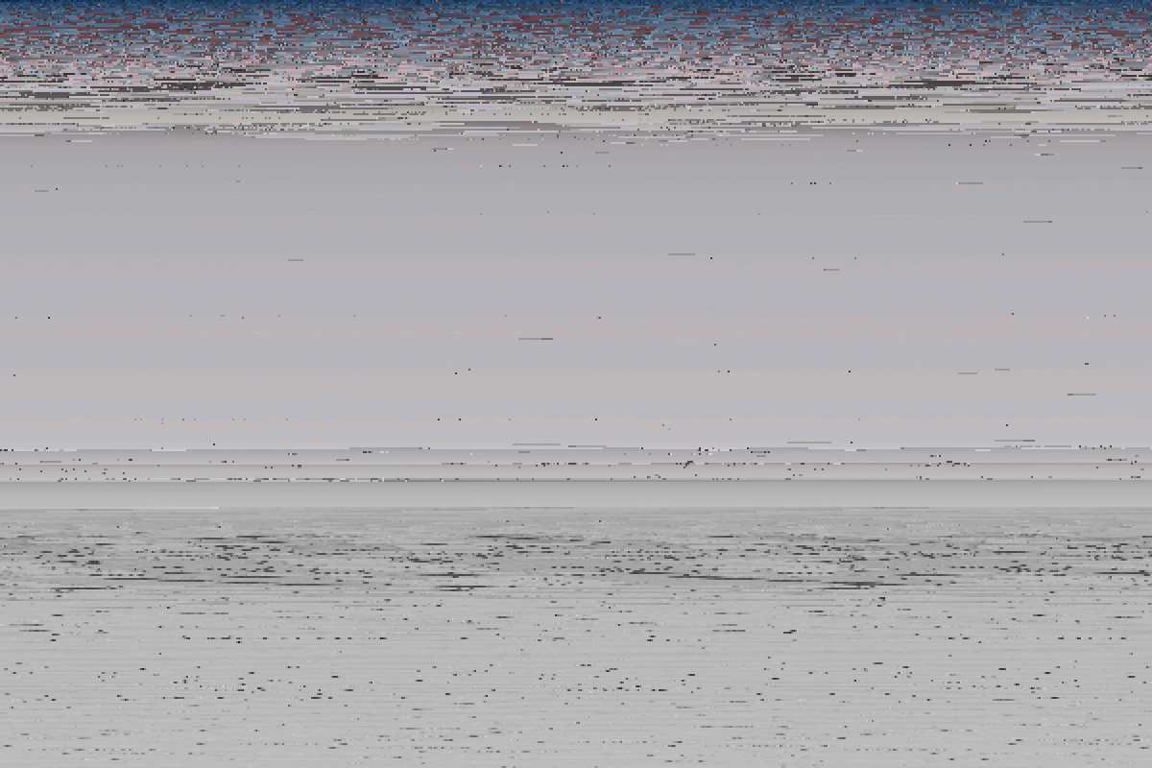
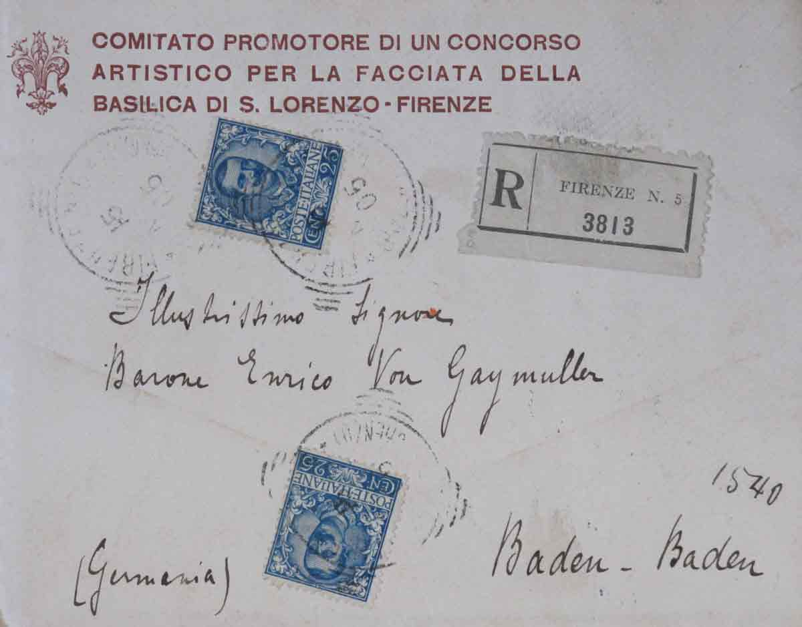
- Well-ordered pixel content of an envelope. (Author)
Always regarding the quality of sources in the context of other sources as well as in the overall context is the essential insight. When the sum is reduced, the cognitive quality of individual archival sources decreases, too. Sighting the entire archive legacy of Geymuller finally confirmed the proposition previously stated. Neither the representation of individually selected archival sources would make sense, nor the digitalisation of the entire stock of more than 71,500 objects would be possible. That is why the stock is differentiated topically. This resulted in a prioritising classification and a selection of about 18,000 archival sources that have to be digitalised. The challenge associated with this reduction consisted in compensating the summary reduction by appreciating the conjunction / performance of archival sources in order to fairly maintain the quality of message.

III. B. The performance of archival sources within an archive or a web application
The work within an archive is shaped by a concatenation of individual insights, which in total joins an entire insight. We tried to construe the two epistemological models of Ehrenfels and Brunswik as connections between the archival source and the archive or the web application.

Example – As we observed the processing of a single sketch of Geymueller’s archive legacy it became visible that we only could convey a single message about the sketch’s semantic features (quickly sketched architectural details) by joining and linking tangible and formal features (texture of paper, curvature of its corners and traces of tearing at the sketch’s long side). It was the comparison to two other archival sources (sketchbook and list) [16] that enabled us to make a clear classification and assignment of the content. The latter could finally be assigned to a specific building that Geymueller had visited and sketched on one of his journeys through Tuscany (see III.C.). Moreover, it could be reconstructed that Geymueller later extracted the sketch from his travel sketchbook in order to file it away with other non-geographic and non-chronological, but topically similar sketches, probably for his work on a publication.

With regard to the relationship between the archival source and the analogous archive it was particularly the unfavourable classification system that was apparent. Contextual search capabilities are barely possible without having more exact knowledge about the entire stock and, for this reason, also without having an expert on board. The digital opening of the archival legacy entails new user profiles and, thus, requires new search capabilities and by association other comprehension criteria. These should partly replace the cognitive processes from the analogous archive and, moreover, also compensate the knowledge about the entire archival stock.

This should succeed if performances between individual messages are considered. In order to attain a qualitative message it is not only necessary to make the sum of individual messages and its performances accessible (see III.A.), but also to crosslink them to individual messages of other archival sources that are topically, chronologically or geographically affiliated (see III.B.). In addition to it, it is necessary to make external objects accessible, i.e. objects that are located outside of the archive (see III.C.).

III. C. The missing semantic referencing with tangible and intangible entities outside of archives

It is necessary to establish conformity between source and object whose ontological prerequisites are largely different, so that their performativity declines. And, due to translation difficulties, breaks and differences are possible. External objects Geymueller referred to in his sources, and whose ontological domain is also verbal and thus ontologically similar, are mainly sources from other collections or archives as well as from publications. Ontologically different objects are mostly tangible entities like artifacts, persons, spaces or things that are located outside of the archive. But, they are semantically related to one or various archival sources in an immediate manner. Intangible objects, by contrast, would be mental processes or actions, which are comprehended in the form of design ideas or a research theory, but also journeys or correspondences are however ontologically alienated. The reference of an archival source to one of these tangible or intangible objects is a particular challenge for the web application. But, in our proposal of technical solution strategies, we exclusively consider tangible objects.

Example – The example of the sketch previously brought in hardly contained qualitative information by itself. Against this background, a concrete statement about its contents could only be made then when its individual messages are interrelated to the ones of other archival sources (in this case, it was a sketchbook and a attached list of architectural objects). This cognitive process accomplished in the analogue archive was not limited to the joining of similar tangible, formal or semantic messages from the same ontological domain, but also referred to the inclusion of an external physical entity, located outside of the archive, in this case to a depicted architecture in Tuscany.

The observation of cognition processes that deal with archival sources during our research project clarified that the “cognition radius”, depending on the expertise, is, in parallel, always expanded by ontologically strange or alienated domains. The bridging of these different knowledge domains requires one or several references that ensure the traceability of considerations and cognition processes. That is why the bridging should also be possible in the web application. Against this background, we faced up to two distinct reference models, one by William James and the other by Bruno Latour. We incorporated both of them into the way of presentation applied in the web application.
In the view of the American philosopher and psychologist William James, a contemporary of Geymueller, reference is to be regarded as intermediation of conformities. This intermediation depends on a) facts, b) relationships with ideas, and c) accordance with other truths which would be assessed with regard to the recent utility [17]. Whereas, Bruno Latour does not consider a reference a correspondence between the archival source and an object that ontologically differs from the source, but a feature of a chain of several transformational steps. In his view, the feature (reference) circulates on the chain [18]. He did not try to establish a direct connection between the ontological domains ‘language’ and ‘thing’, but to consider those transformational steps that are neglected in James’ model. However, in Latour’s view, those are of significance due to losses of conformity that can occur because of them.

Example – Like it is recognisable by the sketch, there were continuously contextual changes in the course of the sketch’s life, starting from the place of emergence up to the place where it is stored today. Thereby, material/matter, form and/or content of the action originally intended by Geymueller transformed multiple times [19].

According to James, the sketch shows content-related conformities with its model. These conformities constitute a reference between the model and Geymueller’s idea. Having regard to other archival sources and the performances of its individual messages (the number invoked on it and the sketchbook including the list deposited), a concrete content-related conformity with an object located outside of the archive can be reached. This conformity, however, requires a complex cognition and is not possible without knowing other archival sources.
By contrast, according to Latour, the sketch does not depict the architecture, but only represents one (or maybe also several) of Geymueller’s ideas about it. Thus, the sketch does not exclusively represent architecture or idea but both of them. It implies the architecture as a ‘thing’ and Geymueller’s ‘mind’ then, as well as the beholder’s ‘mind’ today. According to this, the reference contextually moves on a thread of coincidentally reducing and amplifying steps of cognition [20]. The latter can turn to both directions, to Geymueller’s thoughts, on the one hand, and to the thoughts of the beholder, on the other hand. That is why the sketch does not show a clear reference, but it is “a directionality operator that is only insofar faithful as it allows the transition between what precedes and what succeeds” (Latour, 2002, p. 82; translated from German to English by the paper’s authors).
This consideration finally brought us to the question of what is the prior immediate relation to the sketch and what the afterwards. From this resulted the assumption that, in the case of architecture-related archival sources, the third value of the message quality cannot be accomplished contextually independent. And, in the case of ontologically distinct domains, conformities (James) as well as gaps (Latour) can appear. What prevails always depends on the local or temporal contexts as well as on the tangible, formal or content-related transformational step between the archival source and the preceded or the subsequent one.

Example – The sketch itself does not stand for a semantically qualitative message and is without cross-linking to other archival sources or external objects only a pure aesthetic artefact. It is one of several operators of a chain of transformational and / or cognitive steps, whose advent is neither the exemplary architecture drawn in 1865 and its end, nor a today’s classifying interpretation. The sketch is part of a greater whole, whose cross-linkages among each other circulate, depending on the issue [21].

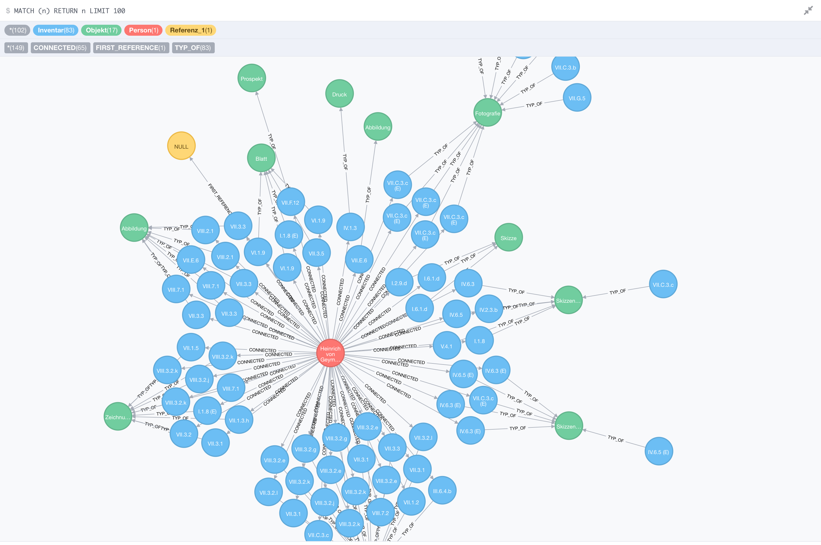
- Network graph – Neo4J realtionship Browser. (Author)

Results – It became apparent that the source as a single information and the archive as a comprehensive information are mutually dependent. On the one hand, the message quality of an archival source is dependent from the systemic layout of the archive. On the other hand, the overall message of the archive also depends from the message qualities of the individual archival sources. Deficits regarding the semantic communication can thus be attributed to the access and the classification scheme of the archive (possibility of cognition) as well as to the missing message qualities of the sources (possibility of messaging).
Our definition of a message quality contains a third message value: the interconnection of an archival source and its knowledge domains that are located outside of the archive. Relationships to real objects and actions that are located or take place outside of the archive are to be regarded as extension of the consolidation of individual messages (features). They are treated according to the way they already were presented within the archive by means of an archival source (see III.A.) as well as several archival sources to each other (see III.B.). These external relationships could, for example, matter between

- an archival source and another source (of another archive, collection, publication,…) [ontologically similar],

- an archival source and a physical entity (tangible artefact, natural object, person,…) [ontologically different],

- an archival source and a mental process or actions (intangible design ideas, research theory, journeys, correspondences,…) [ontologically alienated].

While preparing the web application, we thus faced the challenge to be able to change the chain’s order of the classification assigned to the archival source in the analogue archive. Therewith, we were also able to determine the respective objects adjacent to the archival source in order to establish immediacy in the relationship between them. This also applies to the relationship between the source and an external tangible or intangible object. The final goal of this function is the consolidation of individual information.
The implementation of different XML-based standards (Iconclass, DublinCore, etc.) supports the linking of single archival sources with other objects, as for instance with sources of other archives or publications or physical entities. But, XML-based standardisation is only a formal description of the data structure, which is a problem. Data exchange has to be programmed separately for each archive. According to that, the origin of this problem is the hierarchical structure of XML documents. The ‘common authority file’ (in German: Gemeinsame Normdatei, short form: GND) encompasses, for example, all entities and is a clear reference frame for bibliographic data of libraries, archives, museums and the like. We propose therefore to interlink the archival sources with objects outside of the archive, in urban areas for example, by using the method of geotagging.

Case Study

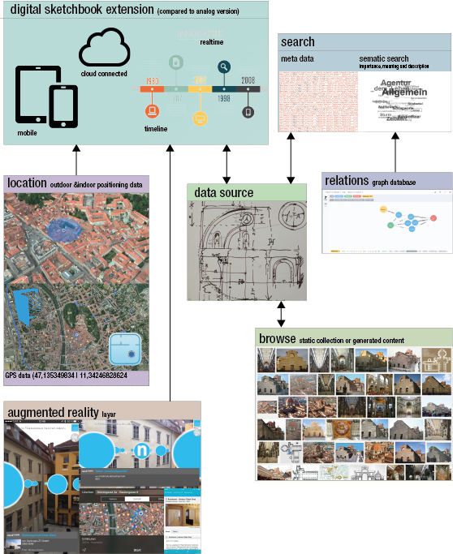
- Conceptual diagramm and application mockup. (Author)

- The Semantic Web (Web 3.0) provides a fundamental data structure and also the principles of usage necessary for this project. It is a web technology that liaises different information from the browser’s search query. It relates them and their connections to each other and evaluates them in their meanings. The aim is to improve the communication between human and computer (human-machine interaction) and achieve higher quality as well as more significance in the search results. The user can formulate an exact enquiry, which is allowed or denied by the web standards, as part of the result viewer on the web, in terms of the expectable search result. The personalisation of content on the Internet is associated with this new development. New personalised web services simultaneously save the user’s behaviour and habits. This extension of the World Wide Web provides data that could be easily evaluated, read by machines and interchanged with other web sources.

Location / geotagging
Image data is the most prominent example for this application. This kind of data generation is an efficient form of including site-specific data. As already mentioned, not only photos can be located by means of geotagging, but also other data. This gives us the opportunity to manage site-specific data. The Geospatial Semantic Web accommodates itself excellently to this project, as the ‘loose’ data structure of the provided data model shows. This enables the provision of a flexible environment for applications that are outside of a pure site-specific model, in which geodata are blended or complemented with native data.
GPS data in a reasonable resolution are currently only offered for outdoor spaces. Localising indoor spaces has already been at the centre of technological developments for quite some time. For example, Google has implemented the ‘function indoor’ since 2011 and allows the user also to navigate inside of the building (e.g. in shopping malls). Moreover, with the ‘project glass’, Google promised 2013 an indoor ‘navigation’ by using its augmented reality glass. Further projects like ‘IndoorAtlas’ [22] or the ‘Indoor Survey’ [23] of Apple also strive in the direction of precisely positioning people indoors (even though these technologies are only provided in commercial facilities that have more than one million customers per year). The technologies for these applications are based on Mesh Networks [24], active iBeacon Networks as well as Inertial Navigation and algorithms that run on image recognition. All of them are premised on radio frequency identification (RFID) [25] and near field communication (NFC) [26].

Semantic Database Solution – The reference-plane model

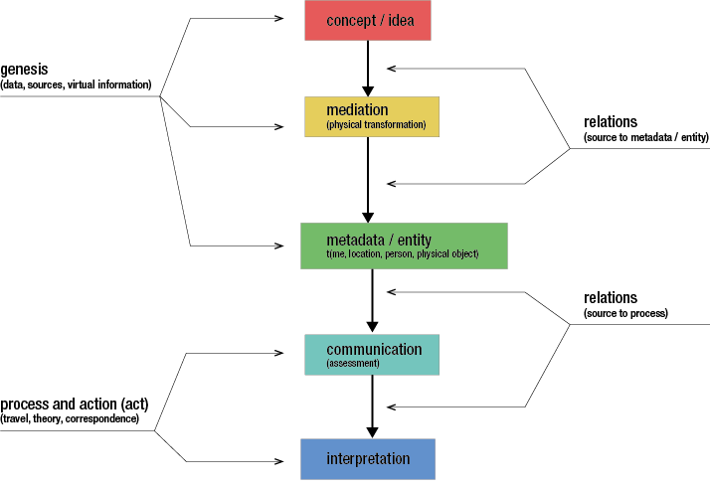

- Reference-plane model as a semantic database solution. (Author)

- The allocation is independent from its genre and orientated not only via form or materiality but also through semantics and performances in connection with other archival sources. The distinction of tangible or intangible object [27] is essential while working with archival sources which are not referring to an implemented or medial object (e.g. archival source in a different archive), as we had to deal with very often in Geymueller`s estate.

The aim of the database is a parallel reference of at least one tangible and one intangible reference. The performance of semantic characteristics of an archival source are described, according to their reference, whether portraying, reconstructing, illustrating or mapping. Besides, the interpretation of the representation remains completely open. This subordinate level refers to those topics, concerning the sources, which are already published. Based on archival sources (image, text, hybrid) they are interconnected with metadata and Thesauri/glossaries. As a result, we gain connections to other databases and a data standardisation. We assume the interconnection of metadata and different reference planes in our data model. Those are organised hierarchically. Moreover, they expand the metadata by other sources (e.g. materialisation and idea or communication and interpretation) and relations that interconnect with intangible characteristics, such as processes and acts/conductions.

Browse – Web application enables browsing and rummaging on site
‘Bibliotheca Hertziana’ [28] and the digital collection of the ‘Schloss Belvedere’, the Belvedere Palace, are already two archives that pursue the same approach we have chosen (‘rummaging and finding’) [29]. Visitors are introduced to the archival stock through compilations and collections. This conforms to the idea of the ‘semi-digitally generated sketchbook’, which is the starting point for further research on the object. While compilations in the Belvedere’s collection are still produced by archivists, we can generate collections automatically by means of search queries.

Augmented Reality [30]
We use this application not only to ensure localisation but the site-specific presentation of data as well. The web app and the users access information on site or link it to the site. The user receives further digital information in real-time, which are presented on a semi-transparent level. Consequently, the recent knowledge is overlaid with related topics, similar information, and consecutive aspects.
Besides the widespread GPS based systems like ‘Layar’ [31] or others [32], there are also technological alternatives available in this area. For example, spaces or objects can be overlaid with particular visual markers (e.g. QR codes [33]) or systems based on image recognition [34]. Modern augmented reality hardware like Oculus Rift, HoloLens, Cardboard VR, etc. makes use of these technologies. Moreover, there is already hardware on the market, which recognises spatial conditions, like a room’s edges and corners, and which operates with [35] or without [36] subsidiary active systems of space measuring (visual laser net).
For the web application in the Geymueller project, it is appropriate to use WebVR 1.0 [37] that is present as a beta version in the Chromium browser and to use one of the GPS based VR frameworks mentioned above.

Cross-linking an archival-source to urban space and its people
Two essential aspects of modern information technologies accompanies the connection between an archival source that is older than 150 years and today’s urban place, where it has been recorded:
1. The digital archive source can be easily taken everywhere. This makes improvements possible in terms of comparisons with physical entities in urban places, such as search options and networking with other archival sources.
2. The search is not limited to metadata and descriptions but expanded by relations between the archival sources, which we define as a precursor for the semantic search.
3. In a semi-digital prototype version new sketchbooks are generated from the specific search entry. The sketchbooks then contain a compilation of archival sources from Geymueller’s archive as well as from other archives, which serve as a starting point for further processing.
4. A semi-analogue sketchbook has the disadvantage that the data from archive-sources and the archive itself can be created only at a specific point in time. In addition, new information that is developed by researchers can only be reintegrated into the archive by digitalisation.
5. Through a digital sketchbook (as web app on a tablet or smartphone) information, sketches, photos, and descriptions can be assigned directly to the archive and the existing archival sources (see 1.). It is possible in this project to use the web app for relationships, as the technical implementation (as graph data with RDF triplets) has no limits (such as the implementation in classical, relational modelled databases).
The archive can thus be expanded in real time. In the analogue archive comments have been left on archival sources, for example, on a drawing sheet from the Geymueller archive. Concerning the web application, however, these comments should be saved on different layers so that other users can decide independently on their presence.

Results – Within the resulting reference-plane model there is no distinction between image and text based data, but the hybrid sources are included. We identified several technologies for the reference-plane model to be outlined in an application prototype. Moreover, for the web application in the Geymueller project, we suggest to use WebVR 1.0 that is present as a beta version in the Chromium browser and also one of the GPS based VR frameworks mentioned above. Finally, there is an existing mockup to be tested in the field. This mockup includes state-of-the-art representation of archival material in museums and is also able and scheduled to be tested in historical urban areas.

Conclusion
The basis of this presented strategy is the data model, developed in the ‘Geymueller’ research project. This model enables the interlinking search of archival sources not only by its metadata (material, formal and content) but also by the performances between the features of the content. Here, the challenge was to relate the linkages of standardised metadata to semantic messages.
A further part deals with the contextualization of the archival sources and urban places, to tangible and intangible objects. It is about relating them to external fields of knowledge by using the method of geotagging. Through the usage of geotagging as a method, we achieved to interlink the archive data with urban spaces and after that providing it for the online user. To accomplish our goal we have to prepare the analogue sources as they are either text-based, image-based, or hybrid sources which need – after being translated into equally searchable data – to be adapted and presented in the Word Wide Web. For all difficulties, which arose as mentioned in the discussion before, we were able to find suitable solutions. The results point out that we are able to connect searchable archive data in an appropriate way and display it then in an online-archive.
The previous discussion shows the broad spectrum of conventional archival work and its challenges by using digital methods based on semantic data structures. With our attempt to reference original archive sources to the location as well as to present them through a user friendly interface, we are able to show valuable connections between tangible and intangible objects via the internet.

References

- Renaissance Architecture – A Digital Anthology of Heinrich von Geymüller (Institute of Art History, University of Graz)
- 2nd DHA Conference of the Austrian Academy of Science, Vienna 2015.
- Aicher, Otl (1991), analog und digital, Frankfurt am Main: Ernst & Sohn.
- Dublincore.org, (2016), [online] Availaible at: http://dublincore.org [Accessed 03/03/2016].
- Loc.gov, (2016) [online] Availaible at: http://www.loc.gov/standards/mets/ [Accessed 01/03/2016].
- Tei-c.org, (2016) [online] Available at: http://www.tei-c.org/index.xml, [Accessed 10/02/2016].

- Wikipedia.org, (2016) [online] Availaible at: https://de.wikipedia.org/wiki/Resource_Description_Framework, [Accessed 12/02/2016].

- http://www.ica.org/10207/standards/isadg-general-international-standard-archival-description-second-edition.html, [Accessed 10/02/2016].

- Tangible, formal and semantic features of an archival source are referred to as ‘messages’ in the following.
- A tangible object is an entity like a thing, a person, a space, an artefact, etc. Whereas an intangible object is a process or action, for example like an outline, an idea or a research intention, can also be a journey or communication etc.
- In order to better understand Geymueller’s methods from an intellectual historical perspective, we considered theories of cognition from the late 19th and early 20th century. These theories were of particular importance with regard to the reconstruction of his project ‘Thesaurus of Architecture’, a large-scale project, that intended to compare all kinds of architectural depictions like drawings, plans or models from various collections. The comparison should be presented in a continuous series of publications [Ploder Josef (1998): Heinrich von Geymüller und die Architekturzeichnung: Werk, Wirkung und Nachlaß eines Renaissance-Forschers, Wien: Böhlau]. The project could not be realised due to financing problems, even though it comprised, for this time, an enormously progressive research approach. With regard to the ideas presented in this paper, we should go on thinking about this approach.
- Ehrenfels, von, Christian (1890), Über Gestaltqualitäten, Vierteljahrsschrift für wissenschaftliche Philosophie, (14), pp. 249–292. Ehrenfels named this model ‘gestalt quality’ und pointed out the example of melody: A melody consists of individual tones. If these tones are transferred to a different key, the tones condition the melody. Wolfgang Koehler, Kurt Koffka and Max Wertheimer later refined this approach [Norberg-Schulz, Christian (1965), Logik der Baukunst, Berlin: Ullstein, pp. 28-34].
- Unlike in a melody, it is not compelling that the order of individual messages of an archival source is always the same.
- Brunswik, Egon (1934), Wahrnehmung und Gegenstandswelt. Grundlegung einer Psychologie vom Gegenstand her, Leipzig: Deuticke, pp. 75.
- Both models are based on the same epistemological and deconstructivist approach from the first half of the 20th century. The structuralist aspects of indirect mental representation [Jungermann, Helmut et al., (2005). Die Psychologie der Entscheidung. Eine Einführung. München: Elsevier 2nd ed. [1st ed, Spektrum Akademischer Verlag: Heidelberg], pp. 176-178.] of this approach have not lost its topicality. Not only are immediately visible and tangible stimuli regarded, but also cognitive processes.
- Kind of labelling, formal similarities of the sketches as well as conformity of the numbering at the top right margin and the one on the list.
- James, William (1907), Pragmatism. A New Name for Some Old Ways of Thinking, Cambridge: MA: Harvard University Press, 1975, 205-244.
James is considered the most significant representative of the ‘pragmatic philosophy’. His theory of truth is shaped by conformities, in a relativistic way, as well as by an utilitarism, by which he tried to especially distance himself from rationalism prevailing in his day.
- LATOUR, Bruno (1999). Die Hoffnung der Pandorra: Untersuchungen zur Wirklichkeit der Wissenschaften, Cambridge, Massachusetts: Harvard University Press, 2002, pp. 84-87.
- Thus, references changed. This also applies to the semantic conformities, which probably have changed for Geymueller, too, by pulling the sketch out of the sketchbook and assigning it to another topical context. In this case, the new context is not only focussed on the architectural form, but on the entire stylistic disposition of Renaissance in Tuscany. Superficially, for Geymuller, it was not only a matter of depicting a model, but of the tendential process of stylistically disseminating. In the individual consideration, he occasionally could notice the latter with regard to this architecture.
- LATOUR, Bruno (1999). Die Hoffnung der Pandorra: Untersuchungen zur Wirklichkeit der Wissenschaften, Cambridge, Massachusetts: Harvard University Press, 2002, pp. 84-87.
- The extended search capabilities of the web application facilitated by the cross-linkage chart have yet revealed, for example, that the sketch is additionally connected to an outline on a transparent paper (probably a transfer) and to a publication draft/ template, which was prepared and should finally be conveyed to a printed publication. The latter represents a knowledge domain of Geymueller that has not been exploited yet, but is available to us in the form of fragments.
- Indooratlas.com, (2015), [online] Availaible at: https://www.indooratlas.com [Accessed 03/03/2016].
- Indoor-Survey-Apples, (2015), [online] Availaible at: http://www.heise.de/mac-and-i/meldung/Indoor-Survey-Apples-versteckte-App-zur-Positionsbestimmung-in-Innenraeu
men-2867087.html [Accessed 29/12/2015].
- Wikipedia.org, (2016), https://en.wikipedia.org/wiki/Mesh_networking [Accessed 12/02/2016].
- Wikipedia.org, (2016), https://en.wikipedia.org/wiki/Radio-frequency_identification [Accessed 23/02/2016].
- Wikipedia.org, (2016), https://en.wikipedia.org/wiki/Near_field_communication [Accessed 23/02/2016].
- An intangible object is descendent from a ontological concrete field and is defined via entities - likewise artefacts, things, rooms or people. This object originates in an ontological mental/intellectual area, and is either defined through a cognitive process or an action. It can for instance rely on what ist called the `concept` (concetto) by the architecture theoretician Giorgio Vasari (1550/1568) - an artifacts underlying idea. She is put into reference to a source object for example, if it refers to an intellectual concept - e.g. a research intention, a design idea or a theoretical reconstruction. The source genres generally most affected are sketches, charts, drawings, reconstruction plans, but also letters and notes, which are linked via content from a journey, fro ma conversation, an idea oder any other cognitive process.
- Biblhertz.it, (2016), http://www.biblhertz.it/?id=49 [Accessed 22/02/2016].
- Digital.belvedere.at, (2016), http://digital.belvedere.at/emuseum/#, [Accessed 16/02/2016].
- Whatis.techtarget.com, (2016), http://whatis.techtarget.com/definition/augmented-reality-AR, [Accessed 02/03/2016].
- https://www.layar.com, [Accessed 26/01/2016]
- Socialcompare.com, (2016), http://socialcompare.com/en/comparison/augmented-reality-sdks, [Accessed 04/03/2016].
- Kan, T.-W., et al. (2009). Applying QR Code in Augmented Reality Applications, Proceedings of the 8th International Conference on Virtual Reality Continuum and Its Applications in Industry, VRCAI ’09. ACM, New York, pp. 253–257.
- Dev.inglobetechnologies, (2016) http://dev.inglobetechnologies.com/index.php, [Accessed 15/02/2016]
- Heise.de, (2016), http://www.heise.de/newsticker/meldung/VR-im-Browser-WebVR-1-0-API-Proposal-vorgestellt-3126776.html?wt_mc=nl.ho.2016-03-04 [Accessed 06/03/2016].
- Google.com, (2016), https://www.google.com/atap/project-tango/, [Accessed 05/03/2016].
- Heise. De, (2016), http://www.heise.de/newsticker/meldung/HTC-Vive-im-Test-Das-Holodeck-begeistert-3120791.html?wt_mc=nl.ho.2016-03-[Accessed 01/06/2016].

